CrashAlert: Enhancing Peripheral Alertness for Eyes-Busy Interaction while Walking

Anonymous 1 | Anonymous 2

ABSTRACT
Divided attention when people multi-task while walking (e.g. texting, browsing the web) can lead them to dangerous outcomes, such as colliding into obstacles or other people. To avoid such risks we introduce CrashAlert, a novel system that uses sensors embedded on mobile devices to extend the user’s peripheral awareness by providing visual cues of the environment in a minimal footprint display on the device. CrashAlert aims at enhancing peripheral alertness and reducing the risk of collisions when walking and multi-tasking with mobile devices. We augment a mobile device with a depth camera and alert the user of the existence of obstacles outside their peripheral view. This paper presents the design and early feedback of CrashAlert. An initial study outside the lab environment showed that with CrashAlert users improve in their handling of potential collisions, and that this handling has no significant effect in task performance. Participants also reported an increased perception of safety, efficiency and alertness. Our results suggest that low fidelity-visualizations (i.e. reduced ambient information) are easily understandable and glance-able, lowering the cost of accessing such information. Finally, the paper discusses how participants used the system not only as an alert mechanism but also as a navigational tool and the need for enhanced alert mechanisms (by type of object, by direction, by speed).

ACM Classification: H5.2 [Information interfaces and presentation]: User Interfaces. - Graphical user interfaces.
General terms: obstacle avoidance, multi-tasking, eyes-on interaction,
Keywords: Eyes-busy interaction, texting and walking, walking user interface.

INTRODUCTION
Mobile device users habitually multi-task (e.g. texting, browsing the web) while walking. Unfortunately, tasks that require a high degree of visual attention or eyes-busy interaction (such as texting) limit much of the user’s peripheral vision. This practice has resulted in users tripping onto curbs, walking into traffic or deviating from their intended path [refs.]. In 2008, eyes-busy interaction while walking led to a twofold increase from the previous year, in emergency related accidents [ref.], forcing some states to introduce new safety policies that ban mobile device usage while walking [ref.]. Policy making aside, technological support for safer walking and multi-tasking is relatively unexplored.
In this paper, we introduce CrashAlert, a system that captures and displays information beyond the user’s peripheral view, using a depth camera attached to a mobile device. CrashAlert has two components: it scans the environment for obstacles on the user’s path, and it alerts users about the position of these obstacles in a minimal footprint display on the mobile screen. We implemented various visual transformations on the scanned image to keep the CrashAlert’s ambient display at its best minimum size (Figure 1).
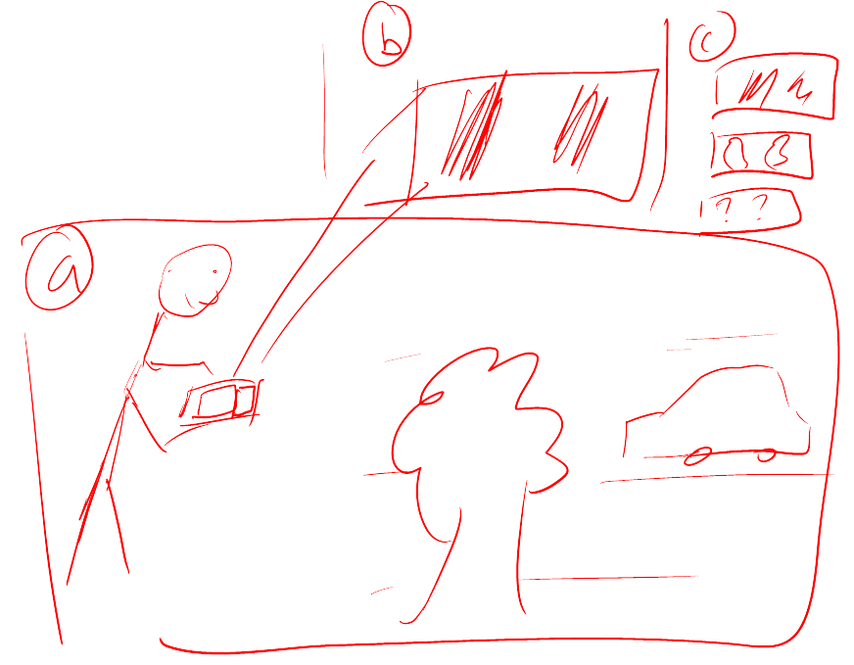
Permission to make digital or hard copies of all or part of this work for personal or classroom use is granted without fee provided that copies are not made or distributed for profit or commercial advantage and that copies bear this notice and the full citation on the first page. To copy otherwise, to republish, to post on servers or to redistribute to lists, requires prior specific permission and/or a fee.
UIST’12, October 7-10, 2012, Cambridge, MA, USA.
Copyright © 2012 ACM 978-1-xxxx-xxxx-x/xx/xx... $10.00.
Figure 1 – CrashAlert senses environmental obstacles through a depth camera and informs the user of their positions in a minimalistic and configurable manner in the device display. Alerts are triggered as the user approaches an object.
We studied the impact of CrashAlert in a collision-prone environment outside a lab environment. Eight participants walked through a cafeteria during busy hours. We provoked potential collisions unknown to the participants by having an ‘actor’ moving head-on or cutting off the user. Results suggest that participants were able to easily interpret our visual alerts, felt safer using CrashAlert even after a short period of use, and their performance was not affected by the visual augmentations. We also found that with CrashAlert users were more proactive in avoiding collisions.
The main contribution of this paper is a demonstration that augmenting a mobile device with additional sensors, such as a depth sensing camera along with a minimal-footprint visual display of the sensor’s data can assist users in eyes-busy interaction while walking. This contribution comes in three parts: (1) a mobile system, CrashAlert, augmented with a depth sensing camera, (2) a set of visual transformations aimed at minimizing screen space and optimizing relevant information, and (3) a study of CrashAlert showing improved handling of potential collisions with no task performance effect.

Related work
We first report on the dangers of multi-tasking while in motion due to limited peripheral alertness and then briefly describe systems aimed at improving eyes-busy interaction while walking (such as walking and texting). CrashAlert’s primary objective is in assisting users to avoid collisions while in motion and we therefore briefly report on assistive technologies for visually-impaired users or for visually-impoverished conditions.

Dangers of multi-tasking and walking
Field studies examining the effect of cell phone use on street crossing behavior have observed that pedestrians cross more slowly when conversing on a cell phone, are less likely to look at traffic before entering the roadway, and make more unsafe crossings compared to non-distracted pedestrians [refs.]. More recently, studies have shown that users can deviate significantly from their walking path when texting and walking [ref.] and hospital reports confirm an increased number of emergency incidences related to mult-tasking/texting while in motion [refs.]. Researchers have also controlled environmental factors (i.e. car speed, traffic density) in virtual reality settings and results confirm the negative effects of multi-tasking while walking [ref.]. The effects worsen with more demanding tasks: pedestrians are less likely to successfully cross a road and take more time to initiate a crossing when conversing on a cell phone than when listening to music.
Results from these studies have mostly guided the efforts of policy makers but also motivate the need for novel technological interventions. Furthermore, while VR studies can control many environmental conditions, we purposefully evaluated CrashAlert in the field to evaluate the potential risks and benefits of providing users with peripheral alertness.

Walking user interfaces
A new line of research in walking user interfaces [Kane] has emerged with the goal of studying and exploring methods to assist users with eyes-busy tasks while walking. Such interfaces have mainly concentrated on aiding users in being more efficient and accurate (therefore indirectly safer) with cognitively demanding tasks such as text-entry when walking. Recent results suggest that audio feedback [ref.] can better guide touch-screen input while walking. Furthermore, to aid users with text-entry while walking, researchers have introduced systems that automatically enlarge soft buttons when in motion [Kane], systems for two-handed chorded keyboard input with a stylus [ref.], and novel adaptive methods that leverage a mobile device’s tri-axis accelerometer to compensate for extraneous movement [ref.].
Relatively fewer technological interventions have been proposed to enhance peripheral alertness while multi-tasking and walking. These are limited to directly displaying the video feed from the mobile’s camera on the screen (WalkNGo) or with some limited processing to show on-coming vehicles (ref.). To the best of our knowledge CrashAlert is the first system to exploit transforming images from a depth camera to provide visually salient information onto a minimal footprint display.

Guidance systems for visually-impaired users
A number of commercially available (i.e. Sendero GPS, Trekker Breeze) and research-based systems [ref.] provide instructions to visually-impaired to assist with navigating and way-finding in an environment. Most of these systems rely on audio cues and recent results suggest that vibro-tactile cues can also be mapped in a spatial manner to guide users in navigating through environments [ref.]. While audio and haptic cues do not consume real-estate space on mobile devices, most of the information is presented serially by discretizing information about the environment. Prototypes closer in practice to our system process the mobile device’s video feed from the environment and alert users about salient attributes, such as pedestrian crossings or whether users are allowed to cross the street [ref.]. These systems rely on a fair amount of processing that may not be practical for providing real-time ambient feedback about peripheral objects,

Field observations
To better understand how users engage with mobile devices while on-the-go we carried out an observational study in public places where people walk while interacting with their mobiles. We observed over forty users in a university cafeteria and at a shopping center perform activities on their mobile devices while walking. We recorded the holding angle of the device, the number of hands used, the number of steps taken before lifting their heads (to detect on-comers and obstacles), the type of obstacles they most commonly avoided, patterns in walking speed, whether they had company, whether they typed, and whether the interaction ended in a phone call. Our data collection was limited to an indoor setting and it is probable that different outcomes would have been obtained by collecting data from outdoor settings as well. However it constitutes a good basis for understanding some of the behavioral phenomenon taking place during eyes-busy interaction and walking.
Our results helped identify … [average tilt angles], [average number of steps], [avoidance strategies: dodging, heads-up, stopping], […].
These observations led to the following considerations relevant for the design of a technical system aimed at helping users avoid collisions:
C1 – Collisions: people slowed down their pace when reaching a crowded area or around known obstacles on their route. In most cases the person multitasking while walking would be the cause of a collision and no other passersby. Therefore, the system should help the user avoid collisions located on their path, possible highlighting the unexpected like people stopping or crossing in front of the user.
C2 – Fallback to vision: Our observations showed that navigating and dodging obstacles and other people without lifting the head is a common practice. However, people fallback to vision in complex situations. Therefore, the system should identify such possible situations and notify users so they lift their heads and sort out the situation.
C3 – Tilt angles: Mobile device users hold their device at different angles, which is important when considering the capture mechanism for determining what lies in front of the user. Therefore, the system should support a configurable or dynamic mechanism in order to meet different users’ preferences.

Design Framework
The design of a peripheral alert system for eyes-busy interaction while walking is influenced by numerous factors including data capture methods, ambient data presentation methods, and notification mechanisms. Environmental factors such as the lighting in the environment, the density (size of crowds), and the specific use context can also affect the design of such systems. However, for this first investigation we focus on the first three design factors.

Data capture methods
Data outside a user’s periphery can be captured in a multitude of ways, but primarily through embedded sensors [ref.] or video [ref.] from the device. Such sensors can ideally capture information about on-comers and moving objects (cars, trucks, etc.), static objects (tables and chairs) or environment features (such as curbs, potholes, stairs). However there is also a limit to how much a user can process while simultaneously performing an eyes-busy task. Based on our observations users are primarily concerned about potential collisions directly in front of them. When faced with known environment features, such as stairways or walls, users generally stop walking. [ENHANCE THIS]

Information presentation
The captured environment data needs to be presented in an ambient and non-intrusive manner to the user [ref.]. Most ambient displays, however, are designed for public or larger displays than those used on mobile devices. This raises challenges in determining how best to present the salient peripheral information using a minimal screen footprint. Alternatives such as audio and haptic displays are also possible. However, audio is limited in noisy environments (unless the user is wearing ear phones) and for rendering spatial information [ref.]. Vibro-tactile displays also do not consume display space and can be rendered with some spatial information [ref.]. However, vibrotactile information is limited in providing context and detail information. Whereas ambient visual presentation consumes display space it also provides maximum flexibility in choosing appropriate renderings of the peripheral environment.

Notification mechanisms
When collisions are imminent, users should be notified of the severity through an alert. Various types of alerts are possible [ref.], including audio, haptic and visual. Since our primary modality for conveying peripheral information is through visual means we also provide visual alerts in our system. [ENHANCE THIS]

CrashAlert
Figure 2 presents CrashAlert, a system designed to provide users with ambient visualizations and visual alerts to help them avoid obstacles while multitasking on their mobile devices. CrashAlert uses both a depth and a normal camera attached to the device to capture a region in front of the user but outside their field-of-view. This slice of the image is processed and presented to the user on the mobile device.
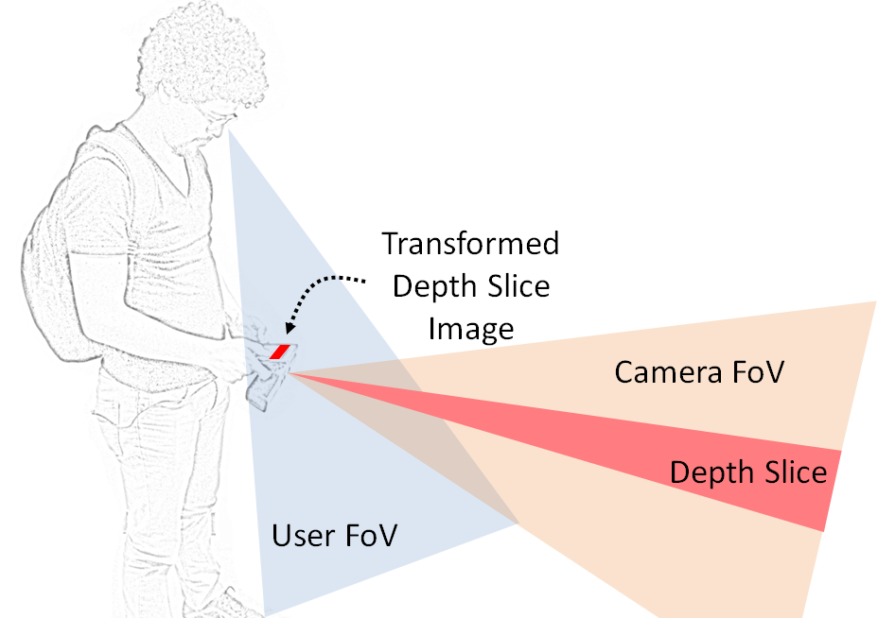
Figure 2 –A depth sensing camera can assist in extending the user’s limited peripheral view. Minimal processing on the a slice of the depth image, or depth slice, can reveal salient information about the environment. Our implementation allows for an adjustable height and position for the Depth Slice.
CrashAlert has three main components: an ambient visual band, visual alerts for near-by objects, and a depth slice. The ambient visualization seeks to convey a glance-able representation of the elements in front of the user (C1), so that they gain an awareness of elements outside their field-of-view as they get closer to objects. CrashAlert allows the user to configure the size of the visualization so that it consumes minimum screen space while providing maximum alertness to users.
The visual alerts are generated from the depth image with objects that are closest to the user within a 2-meter distance. Their appearance (a bright red square in the position of collision, Fig 3) is easily noticeable by the user, causing them to raise their head to better cope with obstacles (C2).
Finally, CrashAlert allows the user to define the region of the source images (depth slice) that better aligns with the front of the walking path according to the user’s particular tilt when holding the mobile device (C3). In our implementation the position and size of the depth slice are manually configured by the user through a settings screen.
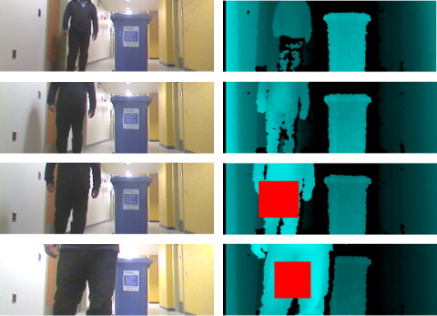
Figure 3 – CrashAlert uses the depth information to determine when an object is closer than 2mts and superimposes a red-square visual alert.
For this early investigation of this design framework, we captured data by means of depth and video cameras affixed to the mobile device, to provide peripheral information from directly ahead of users. CrashAlert approaches information presentation through visual ambient cues. And finally notifications are in the shape of positioned visual alerts and could be augmented with vibro-tactile and audio feedback (which we leave for future work).

Depth Slice
Several alternatives exist for displaying information on CrashAlert’s ambient band (see next section). For example, the entire video image can be squashed onto a small portion of the display. This would make it difficult to identify objects of interest through lack of surrounding context. Alternatively, objects can be placed in a birds-eye radar view. This would lack the advantage of showing the type of obstacles, i.e. person, lamp post, etc which is useful for such tasks (C4). To provide context and details we instead selected a horizontal slice of the image, processed it, and scaled it to the size of the ambient band. In this manner, the user can get a sense of the objects in the scene and their surroundings. By default we fixed the position of the depth slice to pick up information from the lower part of the scene as it could provide sufficient details to avoid many type of obstacles, i.e. walking users, curbs, columns, etc.

Ambient Band
Ambient displays can show environmental information in abstract terms (such as blips on a radar screen), can show the full rendering of information through the video feed, or can show a combination (i.e. through processing the video image). Figure 3 presents four different ambient visualizations provided in our current CrashAlert implementation: (a) depth, (b) depth average columns, (c) depth mask, and (d) columns mask. The depth image is a histogram-based depth image that reduces the depth information (each pixel is a value between 0 and 10000) to a single byte (a value between 0 and 255), and paints then in a gradient from black to green (see figure 3a). The depth average columns image is obtained by applying a binary threshold to the depth image, and calculating the average value for each column of pixels; this average is them assigned to all the pixels in the column (see figure 3b). The depth mask image uses the depth image as a mask on the image captured by the normal camera; this way it shows the full color version of the closest objects on a black background (see figure 3c). Finally, the columns mask image takes the 3b image and increases the value of each non-zero column to 1, this new image is used as a mask on the color image; this way it shows the closest objects plus their surroundings in the vertical dimension (see figure 3d).
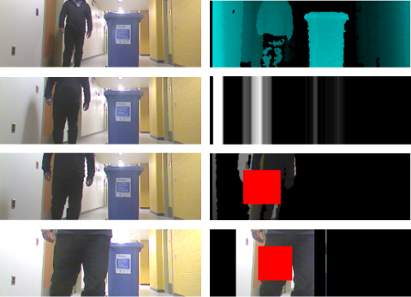
Figure 3 – Visualization types based on given scene.
(a) Depth image shows reduced depth information;
(b) Depth average columns shows depth info as columns;
(c) Depth mask uses the depth image as a mask to a color picture of the same view; (d) Columns mask uses the depth columns image as a mask to a color picture of the same view.

Implementation Details

CrashAlert is a prototype built with an Acer A100 7’’ tablet computer, a laptop computer, and a Microsoft Kinect. The laptop is carried in a backpack together with a 12 volt battery to power up the Kinect. The laptop receives images from the Kinect via USB, processes and transforms them, and sends them to the tablet via Bluetooth. In normal conditions the tablet receives images at a rate of approximately XX frames per second.
At the software level the laptop runs a .NET C# application which interfaces with the Kinect through the OpenNI.net stack, processes the images with OpenCV through the Emgu.CV wrapper, and communicates them over Bluetooth with the 32feet.Net network library. The tablet application is an Android 2.3.3 application with normal Bluetooth permissions.
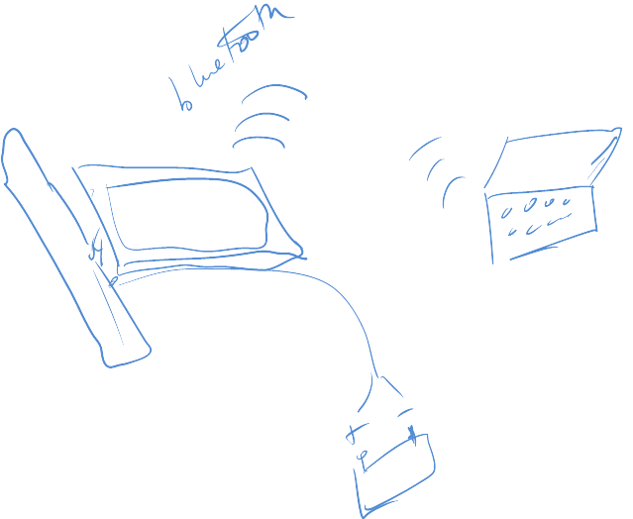
Figure 4 – Mobile tablet augmented with a Kinect depth sensing camera and, communicating via Bluetooth to a laptop. The Kinect is powered by a 12 V battery and inverter.

EVALUATION
Our experiment was designed to observe how users multi-task in a naturalistic environment when using CrashAlert. We recruited university students who habitually text and walk. Eight volunteers (6 male, 2 female, mean age of 25.5 years) from various disciplines. We collected generic data about their own experiences walking and texting. X% said they do this often, although they generally agreed (X.X in a 5 step likert scale) that such practice is dangerous, with an average of XX collisions reported in the last year.
We designed a within-subjects experiment in which participants were exposed to four conditions: (1) no feedback (NF), (2) camera alone (CA), (3) Depth Image (DI) and (4) Depth Mask (DM). Depth Image consisted of using the depth image or the depth columns as from Fig X. The Depth Mask was one of Fig Y or Fig Z. Participants did either type of depth image and depth mask conditions. The camera was fixed at a zero degrees angle and participants were asked to keep the tablet horizontal. The depth slice covered the middle-low 2/5 of the depth and normal images.

Task
We asked participants to focus on the goals of a whack-the-mole game, while walking through the university cafeteria. Each trip consisted of starting the walk at the near-by bookstore and looping around the entire food court. Participants were asked to walk ask normally as possible while playing the game. Their objective was to tap on as many moles as possible during their trajectory. Each trial consisted of one loop around this path. Participants were asked to avoid collisions as naturally as possible. We also assured that participants would face at least four collisions during each trial. This was achieved by asking an ‘actor’, unknown to the participant to behave in certain ways that would lead to potential collisions. The ‘actor’ would cut the participants’ path orthogonally, would stop right in front of them, would come toward them at a fast pace, or would walk with them but then immediately swerve in their lane. We recorded how the participant behaved during all potential collisions.
We captured the user’s total walking time, the number of moles they ‘hit’, as well as the number of times they performed a ‘dodge/slow down’, a ‘heads-up’, a ‘full stop’, and a ‘bump’. Each experiment lasted roughly half an hour. Each condition was done twice, resulting in 8 participants x 4 conditions x 2 trials = 64 trials in total. We also interviewed the participants between trials and at the end of the experiment, and collected data (5-step likert scale) about their perceived safety, efficiency, alertness, walking speed, understandability and glance-ability of each of the conditions.

Procedure
Participants wore the backpack containing the battery pack to which the Kinect was connected to. They were first explained the task and were presented with the different visualizations. We did not inform them of the planned collisions and asked them to behave naturally while trying to complete the whack-a-mole task as efficiently as possible. Participants walked through the cafeteria as per the assigned path.
They completed 2 trips around the path or trials per condition.
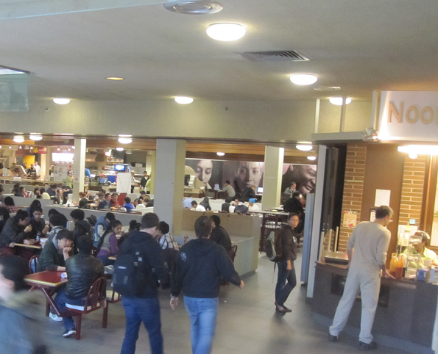 | 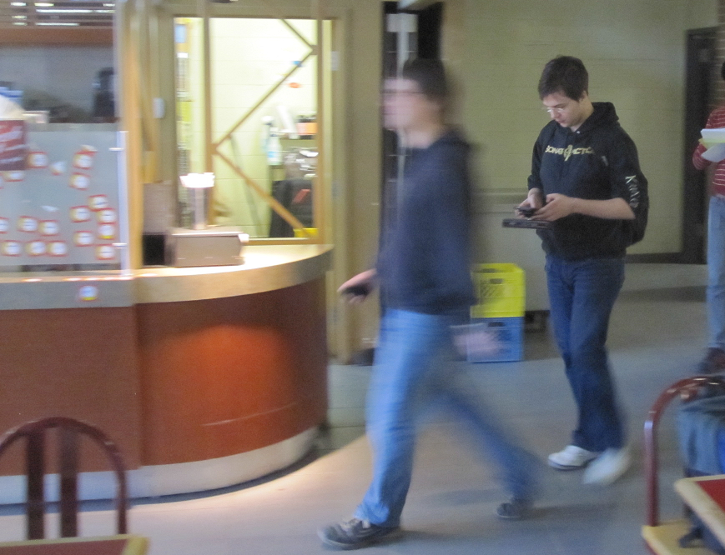
Figure 5 – (left) Experiment setting in university cafeteria. The participant is marked with circle and the ‘actor’ marked with a cross is about to provoke a collision. (right) ‘Actor’ quickly swerves into the participant’s path, the latter is still engaged in the task with the aid of CrashAlert.

Quantitative Results
Each trial lasted 130.5 seconds in average (stdev = 20.8) with an average number of 246.25 moles whacked per trial (stdev = 42.4), and an average error rate of 0.64% (moles missed, stdev = 1.37%). Moreover, participants whacked moles at an average rate of 1.91 moles/second (stdev = 0.04); and therefore the wide spread in the number of moles per trial is explained by the wide spread in completion time.
For the total 64 trials we registered 721 instances of possible collisions with an average of 180.25 instances per condition (stdev = 8.84). Figure XX-top shows the percentual distribution of collision handling maneuvers (dodge/slow-down, heads up, stop before crash, bump) for each condition. The graph shows that using the bumper helped users maneuver through the possible collisions in a smoother way because they could slow down or perform a dodge based on the peripheral information. This better handling came at no cost in playing the game as shown in figure XX-bottom.
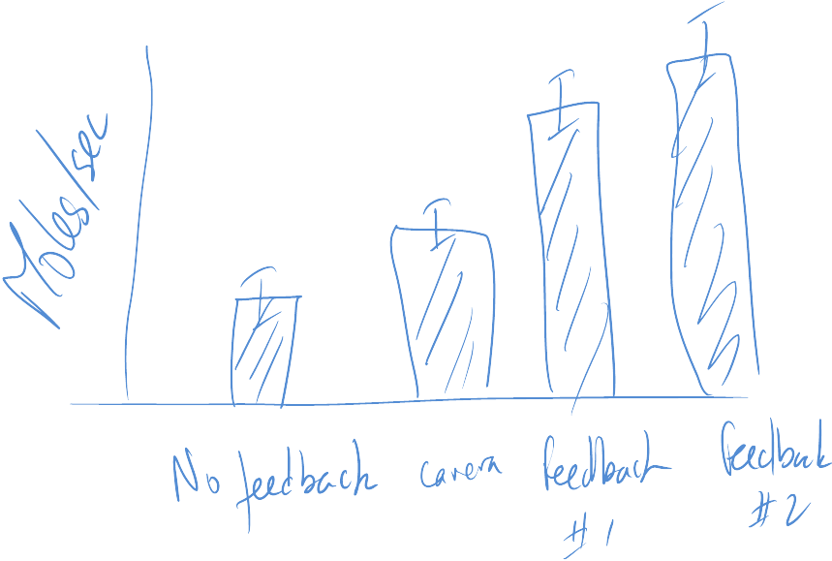
[GRAPH OF THE PERCENTUAL BARS AND THE ERROR RATES]
The post-experiment survey results (see figure YY) showed that, when using CrashAlert, participants felt a higher degree of safety and alertness, and even though there was no real performance gain, participants perceived their task performance as more efficient. Moreover, participants perceived the depth image visualizations as more understandable and glance-able compared to the depth mask condition.
[GRAPH OF THE LIKERT SCALE POST-EXPERIMENT QUESTIONAIRE RESPONSE]

Qualitative Results

We interviewed each participant after each trial and had a longer debrief after the whole experiment. We coded their answer into 19 tags and 4 topics as shown in table AAA. In this section we present the results around three of the topics resulting from our coding: abstraction, navigation and alert. The fourth topic is technical improvements which will be considered for future designs.
In terms of the abstraction level of the visualizations, participants said that even though the full raw video and the depth mask images provide for higher levels of detail they are nonetheless harder to read, requiring more attention and generating more stress when executing the task (even though we did not find any significant impact in performance); for example participant 8 said “I have to check the [color] image much more and longer”. In contrast, the images in the depth condition were found easier to read “at a glance”. Depth images communicate information that would have taken longer to read in the other color or mask conditions; like for example participant 7 said “[with the depth image] I can see the [thin] veranda which I couldn’t in the normal video”. Moreover, participants reported depth images as falling into the background to the point that some users were not sure whether they were using them.
Participants talked about the different ways that CrashAlert enhances their current navigational tools (sound, peripheral view and knowledge of the environment) beyond simply noticing and alerting about obstacles and potential collisions: (1) walk into the dark and (2) follow the alert. Some participants found it useful to simple relax and follow the darker areas of the depth images, as they trusted there would not be obstacles in that direction. In a different situation, when walking through a narrow and crowded corridor, a participant knew the person in front of him (shown with an alert due to their closeness) was walking on the same direction and so he decided to follow to alert in order to go through the crowd.
Finally, participants also noted that a system based only on alerts (no color, depth, or mask image) would already be an advantage compare to having nothing. Moreover, participants indicated the need for different alert types. One such type is alerts based on direction and speed; for example, participant 1 said “I couldn’t tell whether people where coming toward me or moving further away”. Another type is alerts based on the type of object (static or moving object) and their related hazard estimation; for example participant 3 noted “[I would like to see] a significance level indication of obstacles like how much danger if collision occurs”, and participant 5 said “perhaps I could be alerted about different objects in different ways… moving people and static chairs require me to take action differently considering time and predictability”.
Topic | Tags
Alerts | Alert by direction (1), alert by type of object (5), no haptic (1), alert alone (4), alert by speed (1), sound (1).
Abstraction | Gradient easier to read (2), not sure of use (2), color/masks attention demanding (6), color/masks gives more details (1), depth easier to read (2), depth fall to the background (1).
Navigation | Navigating by dark (3), navigating by following an alert (1), environmental knowledge (4), sound + peripheral view (2).
Improve… | More range (2), trust (3), more frame-rate (3).
[TABLE NUMBERING AND CAPTION]

Discussion
Our informal observations and user feedback support the use of CrashAlert in avoiding daily encountered obstacles while multi-tasking on the mobile phone. Users were able to dodge passer-bys or ensure reliable avoidance while multi-tasking. We discuss our overall observations, the limitations of our current system, and provide some recommendations to designers.
C4 – Obstacle types: People avoid a large number of obstacle types, such as passersby, inert objects such as tables and objects in the environment, such as columns. Such objects are clearly pinned to the ground suggesting that seemed to want to distinguish between different types of obstacles, such as on-comers, people moving along with them or inert objects. The system should therefore account for the speed of objects in the environment.

Design Space

FOV mismatch
With these existing systems little is known about how much overlap exists between the user’s field of view and the camera’s field of view, i.e in other words the two FoVs overlap and are not complementary.

Depth Feedback Assists in Obstacle Avoidance

Effect of Visual Feedback on Obstacle Avoidance

Object Overlays Show Improved Performance

Policies
Talk about government policies. Perhaps policies can enforce that texting and walking be done only if users use systems such as BumpAlert to help avoid obstacles. Much testing is however necessary before such policies can be instilled.

Limitations

Recommendations to Designers

Soft

Conclusion

REFERENCES
- Brewster, S. 2002. Overcoming the lack of screen space on mobile computers. Personal and Ubiquitous Computing, 1 (2), 81-96.
- Goel, M., Findlater, L., Wobbrock, J.O. (2012) WalkType: Using Accelerometer Data to Accomodate Situational Impairments in Mobile Touch Screen Text Entry, to appear CHI 2012.
- Kane, S.K., Wobbrock, J.O. and Smith, I.E. (2008) Getting Off the Treadmill: Evaluating Walking User Interfaces for Mobile Devices in Public Spaces. Proc. MobileHCI’08, 109-118.
- Nasar, J., Hecht, P., Wener, R. (2008) Mobile telephones, distracted attention, and pedestrian safety. Accident Analysis & Prevention 40, 69–75.
- Neider, M.B., McCarley, J.S., Crowell, J.A., Kaczmarski, H., Kramer, A.F. (2010) Pedestrians, vehicles, and cell phones, Accident Analysis & Prevention, 42(2), 589-594.
- San Diego News (2012) How Risky Is Texting While Walking? http://www.10news.com/news/30530401/detail.html, last accessed: April 2012.
- Stavrinos, D., Byington, K.W., Schwebel, D.C. (2011) Distracted walking: Cell phones increase injury risk for college pedestrians, Journal of Safety Research, 42(2), 101-107.
- Stewart, J., Bauman, S., Escobar, M., Hilden, J., Bihani, K., & Newman, M. W. (2008). Accessible contextual information for urban orientation. UbiComp ’08, 332–335.
- TIME Magazine - Friedman, M. (2011), http://newsfeed.time.com/2011/01/27/can-lamakers-ban-texting-while-walking/, last accessed: April 2012.
- Yatani, K. and Truong, K.N. 2009. An Evaluation of Stylus-based Text Entry Methods on Handheld Devices Studied in Different Mobility States. Pervasive and Mobile Computing, Vol. 5, No. 5, 496-506.
- Yatani, K. and Truong, K.N. (2009) SemFeel: a user interface with semantic tactile feedback for mobile touch-screen devices. UIST 2009, 111-120.
- Uddin, M.S. and Shioyama, T. (2005) Detection of pedestrian crossing and measurement of crossing length - an image-based navigational aid for blind people. In Trans. on Intelligent Transportation Systems. IEEE, 2005.

The columns on the last page should be of approximately equal length.

http://acer.us/ac/en/US/content/iconia-tab-a100
http://www.openni.org/
http://opencv.willowgarage.com/wiki/
http://www.emgu.com
http://inthehand.com/content/32feet.aspx

